UHF integrated reader
LTR-9906

LTR-9906 is a high-performance UHF RFID read and write device with integrated antenna and reader, Fully independent intellectual property rights design, Support for the ISO18000-6C protocol, Working frequency band covers GB 920MHz ~ 925 MHz (standard), FCC 902MHz ~ 928 MHz (optional), ETSI 865MHz ~ 868 MHz (optional) output power 33dB ± 1dB adjustable, With a beautiful appearance, it is Long identification distance, fast speed, high accuracy, high protection and convenient installation and use characteristics, It can be widely used in logistics management, access control system, anti-counterfeiting system and intelligent production process control and other wireless radio frequency identification (RFID) systems.

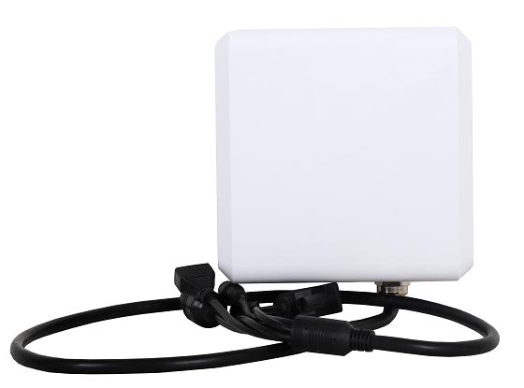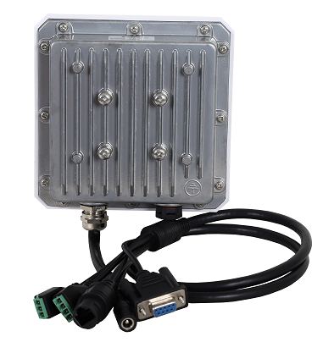
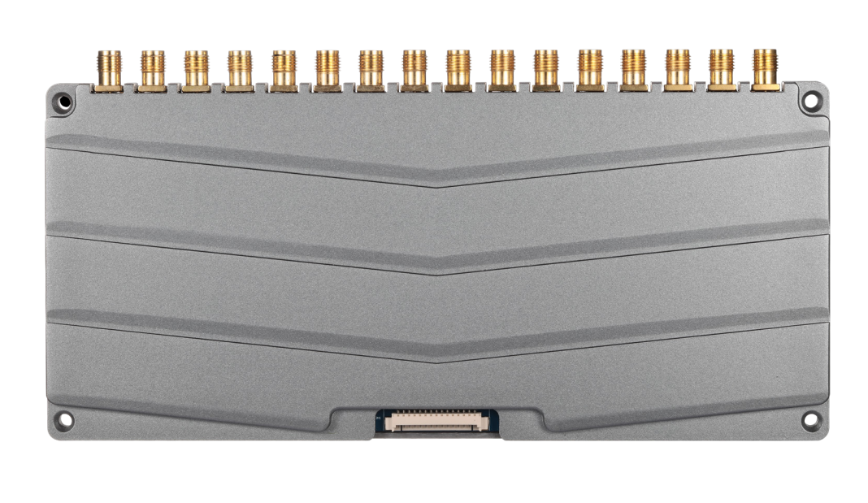

functional characteristics
- High-performance multi-label recognition algorithm, unique l-Serch multi-label recognition algorithm, provide ultra-high recognition efficiency. Maximize multi-label read speed and spiritual density.
- Two label inventory modes. After the cache mode reads the label, then put the cache and filter the duplicate data. There is no redundancy. The real-time mode reads the tag and uploads it immediately, and the user can get the tag data in the first time.
- RF amplifier status detection. Monitor the operating state of the RF power amplifier to ensure that the power amplifier is not saturated. Ensure the long-term and stable work.
- Antenna connection status monitoring.
- Simple and efficient instruction system. The instruction system based on serial port is simple, efficient, convenient and fast integrated.
- Outstanding heat dissipation design. All heating devices have thermal conduction structure, large area of heat sink contact surface. The thermal coupling interface adopts a fixed material with high thermal conductivity and is not volatile at high temperature.
- Support label data filtering, has a flexible data filtering mode, and can accurately screen the target label in the actual application process
- It supports intensive card reading and adopts the optimal design scheme to maximize the frequency interference and communication conflicts between module channels
- Support the RSSI function, the label signal strength can be judged at any time in the actual application process, and optimize the label application in time
- A 6 dBi customized circular pole antenna is embedded, combined with the integrated structure design of the reader, the integrated performance of the antenna is fully optimized, and the typical read distance can reach 10 meters
- Support 1 external antenna interface expansion, realize fixed one machine dual use, achieve fixed / separate antenna dual combination (optional)
- Rich communication interface, support Ethernet / RS-232 / RS-485 / Wei and other communication modes
- The I / O interface supports 2 optical coupling input and 2 relay output
- Using a mature and reliable, multiple verification of the dense circuit design, can be all-weather uninterrupted operation
- Provides demonstration D EMO software for secondary development

Typical application
- Intelligent vehicle management, such as vehicle inspection, customs clearance, vehicle license inspection, etc.;
- Anti-counterfeiting identification;
- Production automation, process management of parts and components;
- Logistics industry, such as container operation management, warehouse inventory management, goods allocation and tracking;
- Electronic ticket inspection and personnel card card inspection;

Specification parameters

Physical parameters
outline dimension | 133mm×133mm×51.8mm
weight | 0.8K g
pigment | Milk white (face shell color) + silver gray (back shell)
Case material | Engineering plastics + cast aluminum
Stick diameter | φ 40～φ50mm
levels of protection | I P67
The UHF technical parameters
Air protocol | EPC global UHF Class 1 Gen2 (ISO 18000-6C)
functional characteristics | Support intensive read and write, multi-label identification, label data filtering, support RSSI, and sense signal intensity
service frequency | GB ：920MHz～925MHz 、ETSI ：865～868MHz  FCC: 902 ~ 928 MHz, full channel: 860-960 MHz
RF output power | 33dBm
work pattern | Fixed / frequency hopping is optional; single / intensive
Output power regulation | Step 1 dB
antenna gain | 6dbi
Antenna specifications | Embedded type, circular polarization
standing-wave ratio | ≤1.3
Continuous read label distance | Up to 10 m (related to tag chip performance and usage environment)
Continuous write label distance | 3 m (related to label chip performance and usage environment)
External communication interface | TCP / IP, RS232, GPIO, RS485, optional weigen 26 / 34 interface and other user interfaces
work environment
working voltage | DC9~28V
working temperature | -40℃～+55℃
storage temperature | -40℃～+85℃
Working humidity | From 10% to 95% RH without condensation
support
D | UHF Demo Software;  Provide SDK development package, and C, C #, Java development etc;  Development guidance and a user manual

Structure size diagram

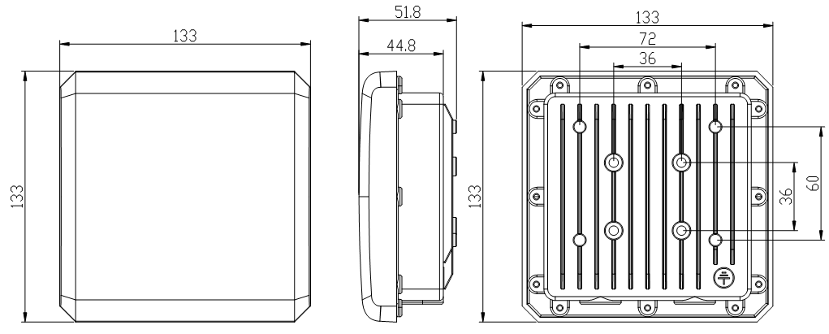

Schematic diagram of installation
